Download DBeaver : https://dbeaver.io/
Download latest club public database : http://prompts.aidg.club/backup.db
Go to https://github.com/NeoClubAIDS/AIDSPrompts/tree/main/db and grab aiprompts.sql to install the structure of the database (PHPmyadmin or other.)

Open DBeaver

New Connection :

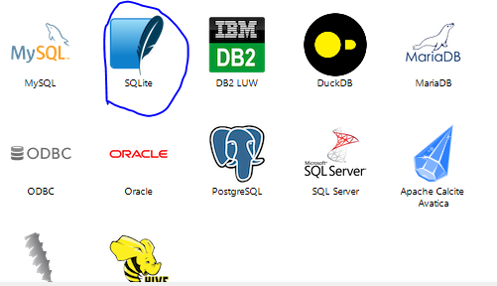

Then choose the old database.

Do another for the MySQL Database :

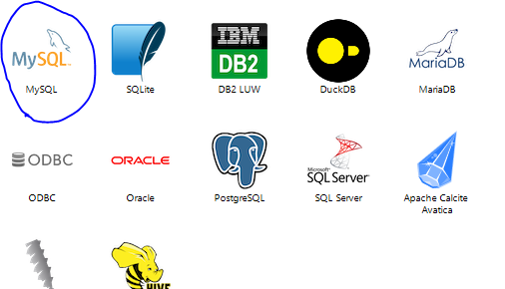

And register your new database.

Go to Prompt in the old database :

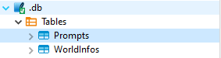

Export Data -> Database

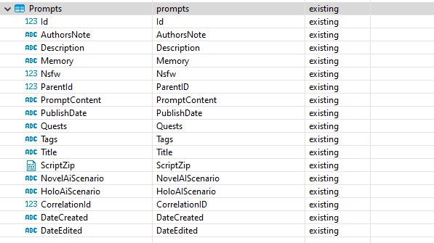

In target choose prompts on the new database.

Then press Next until it’s over.

Do the same for WorldInfos but be sure Keys match WKeys (MySQL didn’t want the name Keys for the column)

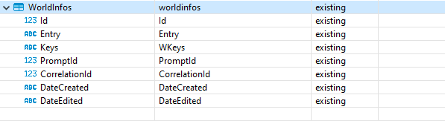

On your new database do :
UPDATE `prompts` SET `PublishDate`='2020/11/15' WHERE `Id`< 1000 and `PublishDate` is null;

